Q1 – Constructors and Constructor Overloading 6 Marks
Bloom’s Level: K5 – Evaluate
Problem Context – Library Book Records
A library creates Book objects in several situations: a new book with full details, a donated
book with only a title, and an empty record that will be filled later. Some records were
created with garbage values in the number of copies.
Implementation Tasks
You must:
• Write a default constructor, a parameterised constructor and overloaded constructors
for the three situations
• Use a member initializer list in every constructor
• Use constructor delegation to avoid repeating code
• Show that no Book can be created with an invalid number of copies

Design & Analysis
You must:
• Explain when the compiler supplies a default constructor and when it does not
• Explain why member initializer lists are preferred to assignment inside the constructor
body
• Explain the order in which members are initialised (declaration order, not list order)
• Draw the state of three objects after construction

Experimental Investigation
You must:
• Create Book objects with every constructor and print them
• Remove the default constructor and record the compiler error when an array of Books
is created
• Demonstrate a member initialised in the wrong order and the -Wreorder warning
• Test a negative number of copies

Design Question
When should a constructor be marked explicit? Show a call that compiles without explicit
and fails with it.
Alternative Concept and Complexity Analysis
If one constructor with default arguments (Book(std::string t = "", int copies = 0, ...)) were
used instead of several overloaded constructors and delegation, what would the solution be?
Analyse the time and space of object creation (O(1) in both) and compare which design
checks the number of copies in fewer places.

Program:
#include <iostream>
#include <string>
using namespace std;

class Book
{
string title;
int copies;

public:
Book() : Book("Unknown", 0) {}

Book(string t) : Book(t, 1) {}

Book(string t, int c) : title(t), copies(c >= 0 ? c : 0)
{
}

void display()
{
cout << "Title: " << title << endl;
cout << "Copies: " << copies << endl;
}
};

int main()
{
Book b1;
Book b2("C++ Programming");
Book b3("Java", 5);
Book b4("Python", -3);

cout << "Book 1:" << endl;
b1.display();

cout << "\nBook 2:" << endl;
b2.display();

cout << "\nBook 3:" << endl;
b3.display();

cout << "\nBook 4:" << endl;
b4.display();

return 0;
}
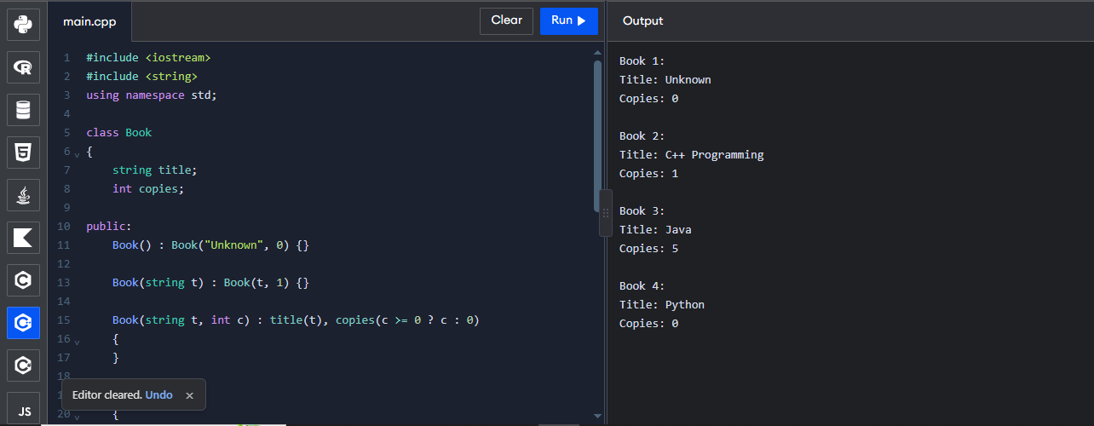

Q2 – Copy Constructors: Shallow and Deep Copies 7 Marks
Bloom’s Level: K5 – Evaluate
Problem Context – Hospital Prescription Records
A Prescription object holds a dynamically allocated array of medicine names. When a doctor
copies a prescription to modify it for a follow-up visit, the original prescription also changes,
and the program sometimes crashes when it ends.
Implementation Tasks
You must:
• Implement the class first without a copy constructor and observe the problem
• Implement a deep-copying copy constructor, a copy assignment operator and a
destructor
• Verify that copies are independent
• Run the program under -fsanitize=address (or valgrind) for both versions

Design & Analysis

You must:
• Draw memory diagrams for a shallow copy and a deep copy
• Explain why the shallow version crashes at the end (double delete)
• State the Rule of Three and explain why the three functions go together
• Explain the three situations in which the copy constructor is called

Experimental Investigation
You must:
• Add a message in the copy constructor and count how many copies are made when a
Prescription is passed by value and by const reference
• Measure the time to copy prescriptions of 10, 1,000 and 100,000 medicines
• Report the sanitizer output for both versions
• Test self-assignment (p = p)

Conclusion
When can you rely on the compiler-generated copy constructor, and when must you write
your own?

Program:
#include <iostream>
#include <string>
using namespace std;

class Prescription
{
int n;
string *medicines;

public:
Prescription(int count)
{
n = count;
medicines = new string[n];
}

// Copy constructor
Prescription(const Prescription &p)
{
n = p.n;
medicines = new string[n];

for (int i = 0; i < n; i++)
medicines[i] = p.medicines[i];
}

// Copy assignment
Prescription& operator=(const Prescription &p)
{
if (this != &p)
{
string *temp = new string[p.n];

for (int i = 0; i < p.n; i++)
temp[i] = p.medicines[i];

delete[] medicines;

medicines = temp;
n = p.n;
}

return *this;
}

// Destructor
~Prescription()
{
delete[] medicines;
}

void set(int i, const string &m)
{
medicines[i] = m;
}

string get(int i) const
{
return medicines[i];
}
};

int main()
{
Prescription p(2);

p.set(0, "Paracetamol");
p.set(1, "ORS");

Prescription q = p;

q.set(1, "Cetirizine");

Prescription r(1);
r = p;

p.set(0, "Ibuprofen");

cout << p.get(0) << " " << p.get(1) << " | "
<< q.get(0) << " " << q.get(1) << " | "
<< r.get(0) << " " << r.get(1) << endl;

return 0;
}
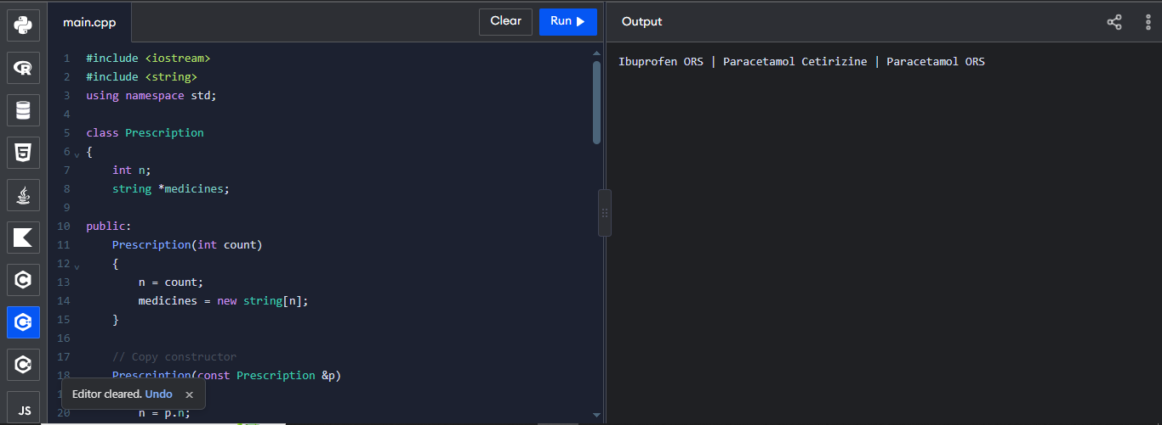

Q3 – Dynamic Constructors and Destructors 7 Marks
Bloom’s Level: K5 – Evaluate
Problem Context – Auditorium Seat Booking
An auditorium’s seat map is created when an event is set up; the number of rows and seats
per row differs from event to event. When the event object is destroyed, all memory must be
released and a closing summary written.
Implementation Tasks
You must:
• Write a dynamic constructor that allocates a two-dimensional seat map with new
• Write a destructor that releases every allocation and prints a summary
• Create events on the stack, on the heap (new/delete) and inside a block
• Book and cancel seats

Design & Analysis
You must:
• Explain the order in which constructors and destructors run for local, block-scope and
dynamically created objects

• Explain what happens if delete is forgotten, and if delete is used instead of delete[]
• Explain why the destructor takes no arguments and cannot be overloaded
• Draw the memory layout of the seat map

Experimental Investigation
You must:
• Print messages in the constructor and destructor and record the order for each kind of
object
• Run with -fsanitize=address, first with a missing delete and then with the correct code
• Measure the memory allocated for 10 × 20, 100 × 200 and 1,000 × 2,000 seat maps
• Test an event with zero rows

Conclusion
How does tying memory release to the destructor (the RAII idea) make the program safer?

Program: 1
#include <iostream>
using namespace std;

class Auditorium
{
int rows, seats;
char **map;

public:
Auditorium(int r, int s)
{
rows = r;
seats = s;

map = new char*[rows];

for (int i = 0; i < rows; i++)
{
map[i] = new char[seats];

for (int j = 0; j < seats; j++)
map[i][j] = 'O';
}

cout << "Auditorium Created" << endl;
}

void book(int r, int s)
{
if (r >= 0 && r < rows &&
s >= 0 && s < seats &&
map[r][s] == 'O')
{
map[r][s] = 'X';
cout << "Seat Booked" << endl;
}
else
cout << "Invalid or Occupied Seat" << endl;
}

void cancel(int r, int s)
{
if (r >= 0 && r < rows &&
s >= 0 && s < seats &&
map[r][s] == 'X')
{
map[r][s] = 'O';
cout << "Booking Cancelled" << endl;
}
}

void display()
{
cout << "Seat Map:" << endl;

for (int i = 0; i < rows; i++)
{
for (int j = 0; j < seats; j++)
cout << map[i][j] << " ";

cout << endl;
}
}

~Auditorium()
{
for (int i = 0; i < rows; i++)
delete[] map[i];

delete[] map;

cout << "Auditorium Destroyed" << endl;
}
};

int main()
{
Auditorium a(2, 3);

a.book(0, 1);
a.book(1, 2);

a.display();

a.cancel(0, 1);

a.display();

return 0;
}
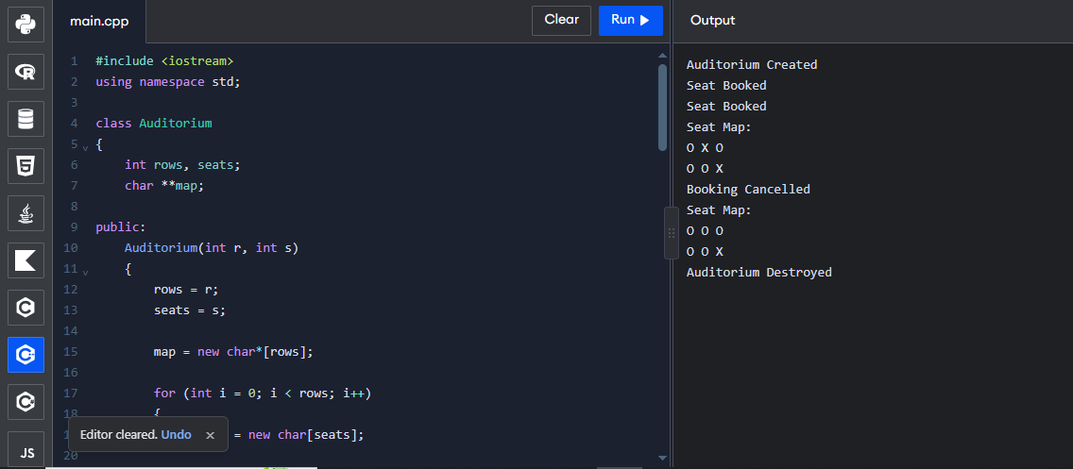

Program: 2
#include <iostream>
#include <string>
using namespace std;

struct Logger
{
string n;

Logger(const string &s) : n(s)
{
cout << "+" << n << " ";
}

Logger(const Logger &o) : n(o.n + "c")
{
cout << "copy" << n << " ";
}

~Logger()
{
cout << "-" << n << " ";
}
};

void use(Logger)
{
cout << "use ";
}

int main()
{
Logger a("A");

{
Logger b("B");
}

use(a);

Logger *p = new Logger("P");

delete p;

cout << "end ";
}
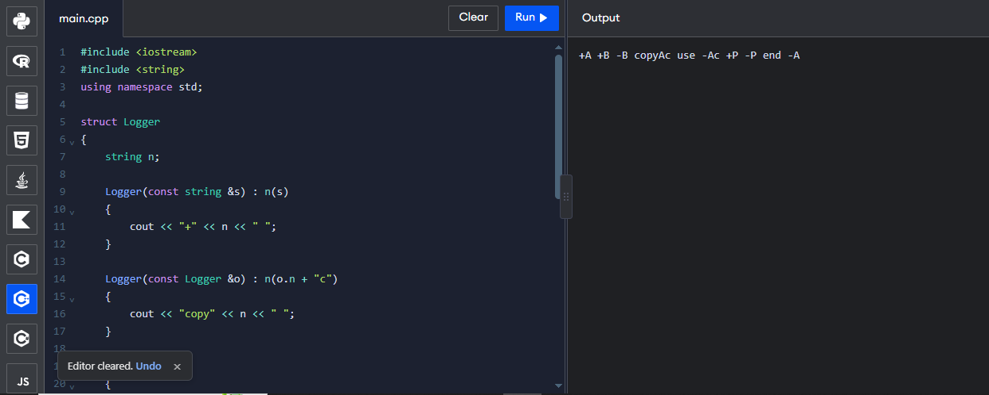

Q4 – Overloading Arithmetic and Stream Operators 7 Marks
Bloom’s Level: K5 – Evaluate
Problem Context – Money Arithmetic for a Billing Counter
A billing counter adds, subtracts and compares amounts of money stored in rupees and paise.
The present code calls functions such as add(a, b) and print(c), which makes the bill
calculation hard to read.

Implementation Tasks
You must:
• Write a Money class storing paise in a long long
• Overload +, -, +=, == and < as appropriate
• Overload << (and >>) for printing and reading amounts
• Write the bill calculation using the overloaded operators

Design & Analysis
You must:
• Explain why + returns a new object while += returns a reference to *this
• Decide which operators are members and which are friends, and justify each
• Explain why << must be a non-member function
• Show how a + b is translated by the compiler into a function call

Experimental Investigation
You must:
• Test addition that carries paise into rupees (Rs 0.75 + Rs 0.50)
• Test subtraction that produces a negative amount and decide how to handle it
• Compare the readability of the bill code with and without operator overloading
• Compare the result with a double-based version for 1,000,000 additions

Engineering Decision
Should Money allow multiplication by another Money? Decide which operators make sense
for money and which do not.

Program:
#include <iostream>
#include <iomanip>
using namespace std;

class Money
{
long long paise;

public:
Money(long long rupees = 0, int p = 0)
{
paise = rupees * 100 + p;
}

Money operator+(const Money &m) const
{
Money temp;
temp.paise = paise + m.paise;
return temp;
}

Money operator-(const Money &m) const
{
Money temp;
temp.paise = paise - m.paise;
return temp;
}

Money& operator+=(const Money &m)
{
paise += m.paise;
return *this;
}

bool operator==(const Money &m) const
{
return paise == m.paise;
}

bool operator<(const Money &m) const
{
return paise < m.paise;
}

friend ostream& operator<<(ostream &out, const Money &m)
{
long long value = m.paise;

if (value < 0)
{
out << "-Rs ";
value = -value;
}
else
out << "Rs ";

out << value / 100 << "."
<< setw(2) << setfill('0') << value % 100;

return out;
}

friend istream& operator>>(istream &in, Money &m)
{
long long r;
int p;

in >> r >> p;
m.paise = r * 100 + p;

return in;
}
};

int main()
{
Money a(120, 75), b(79, 25);

Money c = a + b;

cout << "Addition: " << c << endl;

cout << "Subtraction: " << a - b << endl;

a += b;

cout << "After += : " << a << endl;

cout << boolalpha;
cout << "Equal: " << (a == c) << endl;
cout << "Less: " << (a < b) << endl;

Money x(0, 75), y(0, 50);

cout << "Paise Addition: " << x + y << endl;

return 0;
}
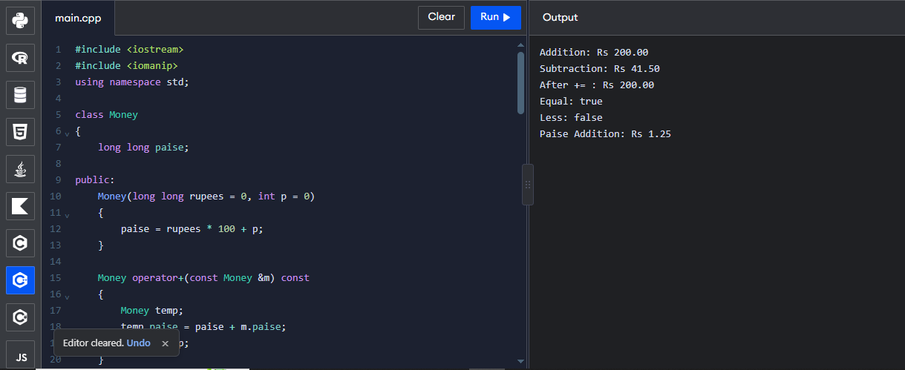

Q5 – Overloading Increment, Comparison and Subscript Operators 6 Marks
Bloom’s Level: K5 – Evaluate
Problem Context – Music Playlist and Track Timer
A music player keeps a playlist of tracks and a Time object for the current position. The
player needs time++ and ++time to advance by one second, comparisons between times, and
playlist[i] to reach the i-th track with a range check.
Implementation Tasks
You must:
• Overload prefix and postfix ++ for Time
• Overload == and < for Time
• Overload [] for Playlist with a range check, in both a const and a non-const version
• Use the operators in a short playback simulation

Design & Analysis
You must:
• Explain how the compiler tells prefix from postfix ++ (the int dummy parameter)
• Explain why postfix ++ must return a copy and is slower
• Explain why operator[] needs a const and a non-const version
• Explain what should happen when an index is out of range

Experimental Investigation
You must:
• Verify the values of a and b after a = t++ and b = ++t
• Measure the time of 10,000,000 prefix and postfix increments at -O0 and -O2
• Test playlist[-1] and playlist[size]
• Test minute and hour roll-over (59:59 → 1:00:00)

Conclusion
Why do many programmers prefer ++i to i++ for class types?

Predict the Output
Write the exact output of the program below BEFORE running it. Then compile and run it,
and explain every difference between your prediction and the actual output.

Program: 1
#include <iostream>
using namespace std;

class Time
{
int h, m, s;

public:
Time(int hh = 0, int mm = 0, int ss = 0)
{
h = hh;
m = mm;
s = ss;
}

// Prefix increment
Time& operator++()
{
s++;

if (s == 60)
{
s = 0;
m++;
}

if (m == 60)
{
m = 0;
h++;
}

return *this;
}

// Postfix increment
Time operator++(int)
{
Time temp = *this;
++(*this);
return temp;
}

bool operator==(const Time &t) const
{
return h == t.h && m == t.m && s == t.s;
}

bool operator<(const Time &t) const
{
if (h != t.h)
return h < t.h;

if (m != t.m)
return m < t.m;

return s < t.s;
}

void display()
{
cout << h << ":" << m << ":" << s << endl;
}
};

int main()
{
Time t(0, 0, 5);

Time a = t++;
Time b = ++t;

cout << "A: ";
a.display();

cout << "B: ";
b.display();

cout << "Current: ";
t.display();

Time x(10, 20, 30);
Time y(10, 20, 30);

cout << boolalpha;
cout << "Equal: " << (x == y) << endl;
cout << "Less: " << (x < y) << endl;

Time z(0, 59, 59);

++z;

cout << "After rollover: ";
z.display();

return 0;
}
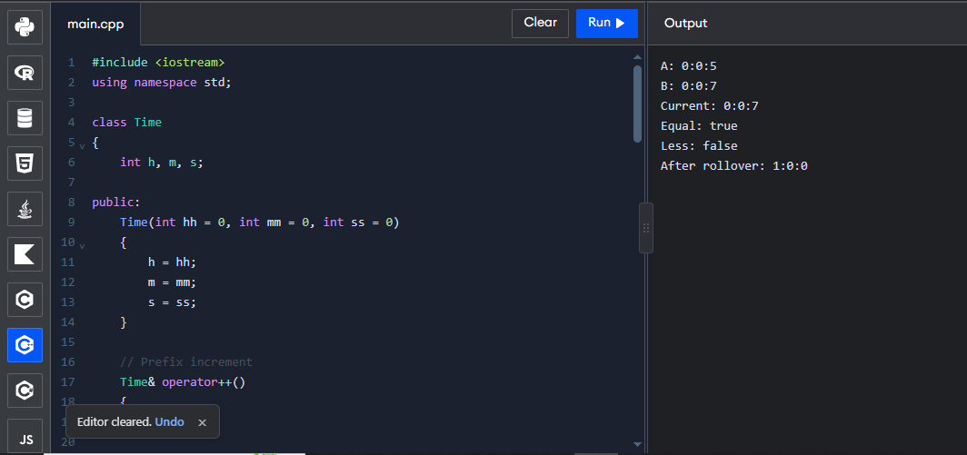

Program: 2
#include <iostream>
#include <string>
#include <stdexcept>
using namespace std;

class Playlist
{
string songs[3];

public:
Playlist()
{
songs[0] = "Song A";
songs[1] = "Song B";
songs[2] = "Song C";
}

string& operator[](int i)
{
if (i < 0 || i >= 3)
throw out_of_range("Invalid index");

return songs[i];
}

const string& operator[](int i) const
{
if (i < 0 || i >= 3)
throw out_of_range("Invalid index");

return songs[i];
}
};

int main()
{
Playlist p;

try
{
cout << "First Song: " << p[0] << endl;
cout << "Second Song: " << p[1] << endl;

p[2] = "New Song";

cout << "Updated Song: " << p[2] << endl;

cout << p[5] << endl;
}
catch (const out_of_range &e)
{
cout << e.what() << endl;
}

return 0;
}
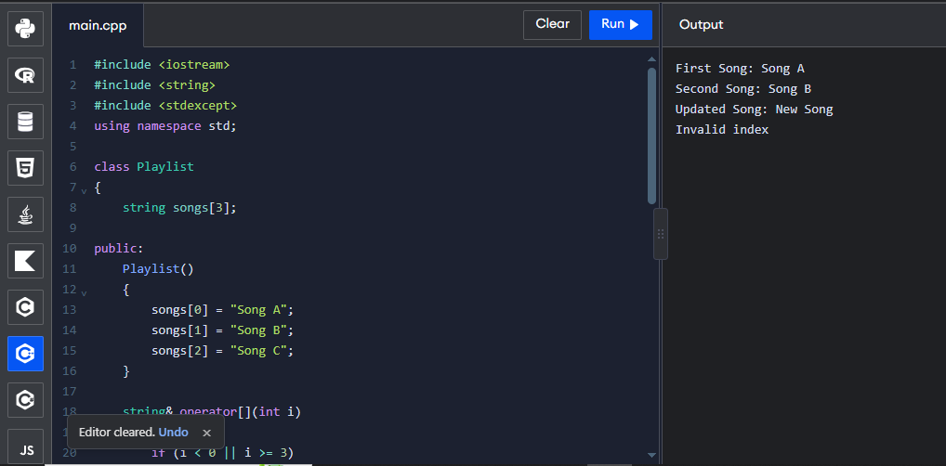

Program: 3
#include <iostream>
using namespace std;

struct Counter
{
int v;

Counter& operator++()
{
++v;
return *this;
}

Counter operator++(int)
{
Counter old = *this;
++v;
return old;
}
};

int main()
{
Counter c{5};

Counter a = c++;

Counter b = ++c;

cout << a.v << " " << b.v << " " << c.v << endl;

return 0;
}
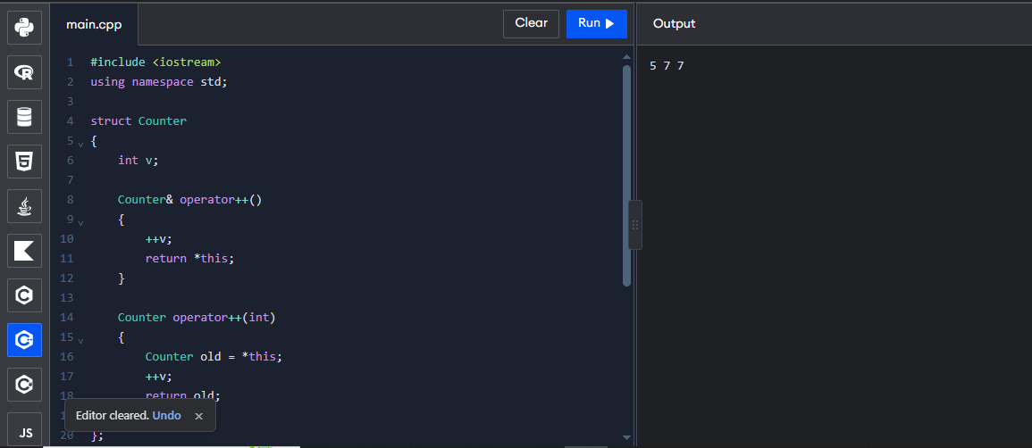

Q6 – The Rules of Operator Overloading 7 Marks
Bloom’s Level: K5 – Evaluate
Problem Context – A Simple Text Class for an SMS Gateway
An SMS gateway uses its own Text class (holding a dynamically allocated character array) so
that it can control memory carefully. It needs assignment, concatenation with +, comparison
and printing.
Implementation Tasks
You must:
• Implement Text with a constructor, copy constructor, copy assignment and destructor
• Overload + for concatenation, == and != for comparison and << for printing
• Prevent self-assignment problems
• Test long messages and empty messages

Design & Analysis
You must:
• List the operators that cannot be overloaded (::, ., .*, ?:, sizeof) and explain why
• Explain the rules: precedence and arity cannot change, at least one operand must be a
user-defined type
• Explain why operator= must be a member function
• Explain when an overloaded operator should be a friend

Experimental Investigation
You must:
• Count the copies made when a + b + c is evaluated
• Run the program under the address sanitizer and fix any reported error
• Compare your Text class with std::string for 100,000 concatenations
• Test assigning a Text to itself

Conclusion
Your Text class works, but std::string exists. What did writing Text teach you, and when
would you still write such a class?

Program:
#include <iostream>
#include <cstring>
using namespace std;

class Text
{
char *str;

public:
Text(const char *s = "")
{
str = new char[strlen(s) + 1];
strcpy(str, s);
}

// Copy constructor
Text(const Text &t)
{
str = new char[strlen(t.str) + 1];
strcpy(str, t.str);
}

// Assignment operator
Text& operator=(const Text &t)
{
if (this != &t)
{
char *temp = new char[strlen(t.str) + 1];
strcpy(temp, t.str);

delete[] str;
str = temp;
}

return *this;
}

// Concatenation
Text operator+(const Text &t) const
{
char *temp = new char[strlen(str) + strlen(t.str) + 1];

strcpy(temp, str);
strcat(temp, t.str);

Text result(temp);

delete[] temp;

return result;
}

bool operator==(const Text &t) const
{
return strcmp(str, t.str) == 0;
}

bool operator!=(const Text &t) const
{
return !(*this == t);
}

friend ostream& operator<<(ostream &out, const Text &t)
{
out << t.str;
return out;
}

~Text()
{
delete[] str;
}
};

int main()
{
Text a("Hello ");
Text b("World");

Text c = a + b;

cout << "Text 1: " << a << endl;
cout << "Text 2: " << b << endl;
cout << "Combined: " << c << endl;

Text d = c;

cout << "Copied: " << d << endl;

cout << boolalpha;
cout << "Equal: " << (c == d) << endl;
cout << "Not Equal: " << (a != b) << endl;

d = d;

cout << "Self Assignment: " << d << endl;

return 0;
}
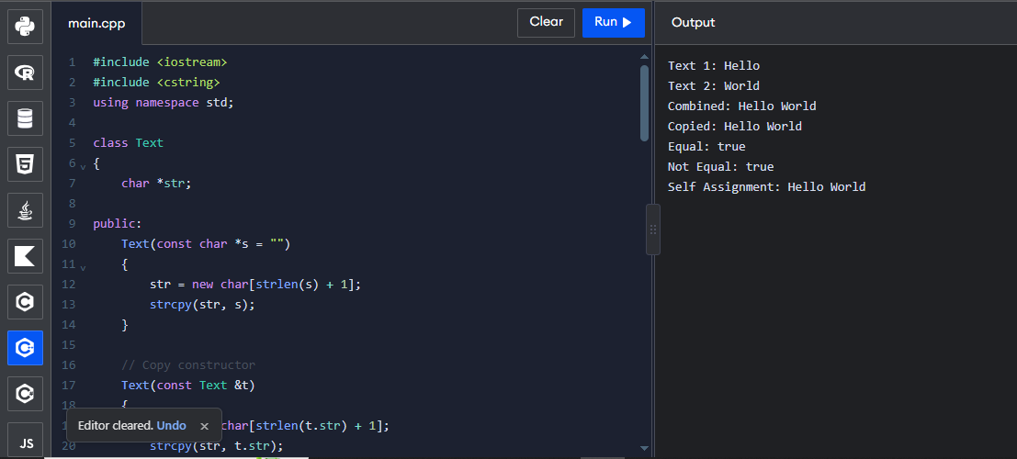

Q7 – Design a Complex-Number Class from First Principles 10 Marks
Bloom’s Level: K5 – Evaluate
Problem Context – AC Circuit Impedance Calculator
An electrical engineering laboratory needs a calculator for AC circuits. Impedances are
complex numbers: resistors give R + 0j, inductors 0 + jωL and capacitors 0 − j/(ωC). Series
impedances add; parallel impedances combine as (Z1 × Z2) / (Z1 + Z2). The calculator must
print the impedance in rectangular form and its magnitude, and must handle division by zero
safely.
You are not given the design. You must develop it from the requirements.
Stage 1 – Interpret the Problem | 2 Marks
• Identify the data and the operations needed
• Identify which constructors are needed (default, from real part, from real and
imaginary parts)
• State the requirements as measurable statements

Stage 2 – Design | 3 Marks
• Design the Complex class with constructors and overloaded +, -, *, /, == and <<
• Decide which operators are members and which are friends
• Present the class design and the formula used for each operator

Stage 3 – Implement and Verify | 3 Marks
• Implement the class and compute the impedance of a series and a parallel RLC circuit

• Verify the results by hand calculation
• Test division by a zero impedance

Stage 4 – Defend the Design | 2 Marks
• Compare your class with std::complex<double>
• Explain why each constructor and operator is needed
• Identify one remaining limitation

Alternative Concept and Complexity Analysis
If std::complex<double> were used instead of your own Complex class, what would the
solution be? Analyse the time per operation (O(1) in both) and the space (two doubles in
both), and compare accuracy and the work needed to handle division by zero.

Program:
#include <iostream>
#include <cmath>
#include <iomanip>
#include <stdexcept>
using namespace std;

class Complex
{
double real, imag;

public:
Complex() : real(0), imag(0) {}

Complex(double r) : real(r), imag(0) {}

Complex(double r, double i)
: real(r), imag(i) {}

Complex operator+(const Complex &c) const
{
return Complex(real + c.real,
imag + c.imag);
}

Complex operator-(const Complex &c) const
{
return Complex(real - c.real,
imag - c.imag);
}

Complex operator*(const Complex &c) const
{
return Complex(real * c.real - imag * c.imag,
real * c.imag + imag * c.real);
}

Complex operator/(const Complex &c) const
{
double d = c.real * c.real +
c.imag * c.imag;

if (d == 0)
throw runtime_error("Division by zero");

return Complex(
(real * c.real + imag * c.imag) / d,
(imag * c.real - real * c.imag) / d
);
}

bool operator==(const Complex &c) const
{
return real == c.real && imag == c.imag;
}

double magnitude() const
{
return sqrt(real * real + imag * imag);
}

friend ostream& operator<<(ostream &out,
const Complex &c)
{
out << c.real;

if (c.imag >= 0)
out << " + j" << c.imag;
else
out << " - j" << -c.imag;

return out;
}
};

int main()
{
double R = 10;
double L = 0.1;
double C = 0.001;
double f = 50;

double w = 2 * 3.14159265 * f;

double XL = w * L;
double XC = 1 / (w * C);

Complex Zr(R, 0);
Complex Zlc(0, XL - XC);

Complex series = Zr + Zlc;

cout << fixed << setprecision(2);

cout << "Resistor: " << Zr << endl;
cout << "Inductive-Capacitive: " << Zlc << endl;

cout << "Series Impedance: "
<< series << endl;

cout << "Magnitude: "
<< series.magnitude() << endl;

try
{
Complex parallel = (Zr * Zlc) / (Zr + Zlc);

cout << "Parallel Impedance: "
<< parallel << endl;

Complex zero(0, 0);

Complex result = Zr / zero;
}
catch (const exception &e)
{
cout << "Error: " << e.what() << endl;
}

return 0;
}


